# CS 255 System Design Document Template

## UML Diagrams

### UML Use Case Diagram

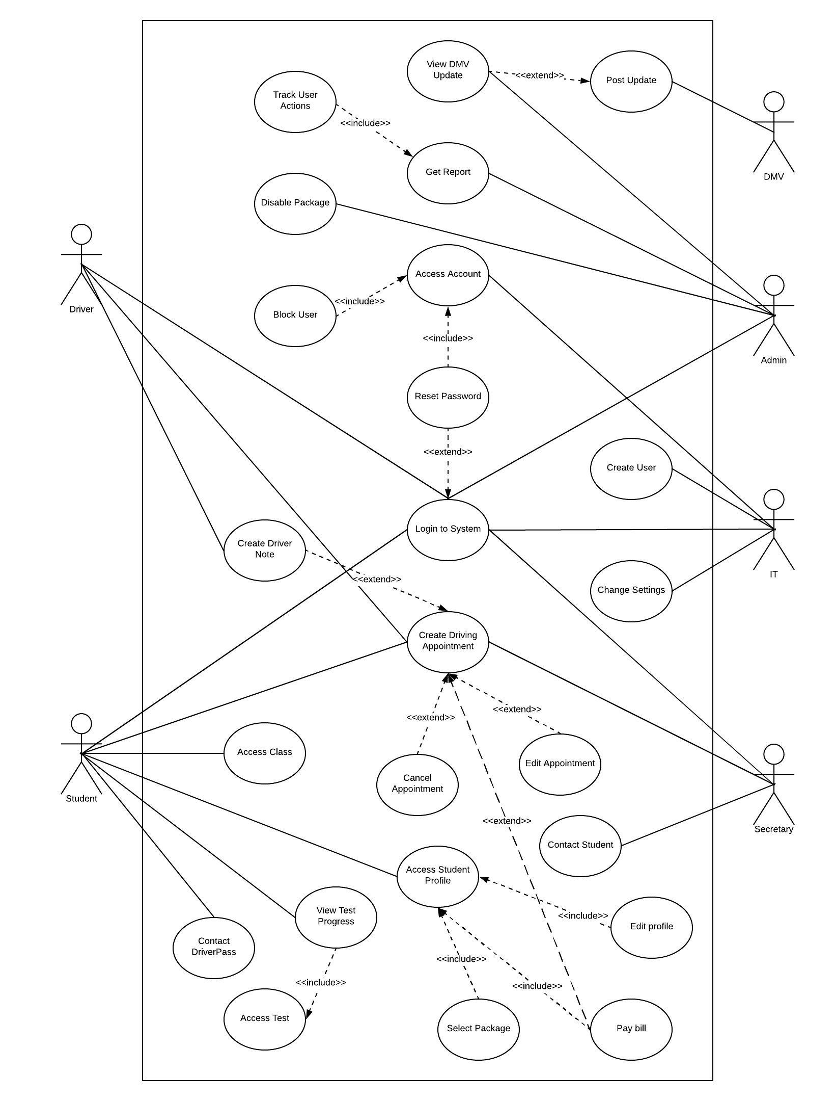

### UML Activity Diagrams

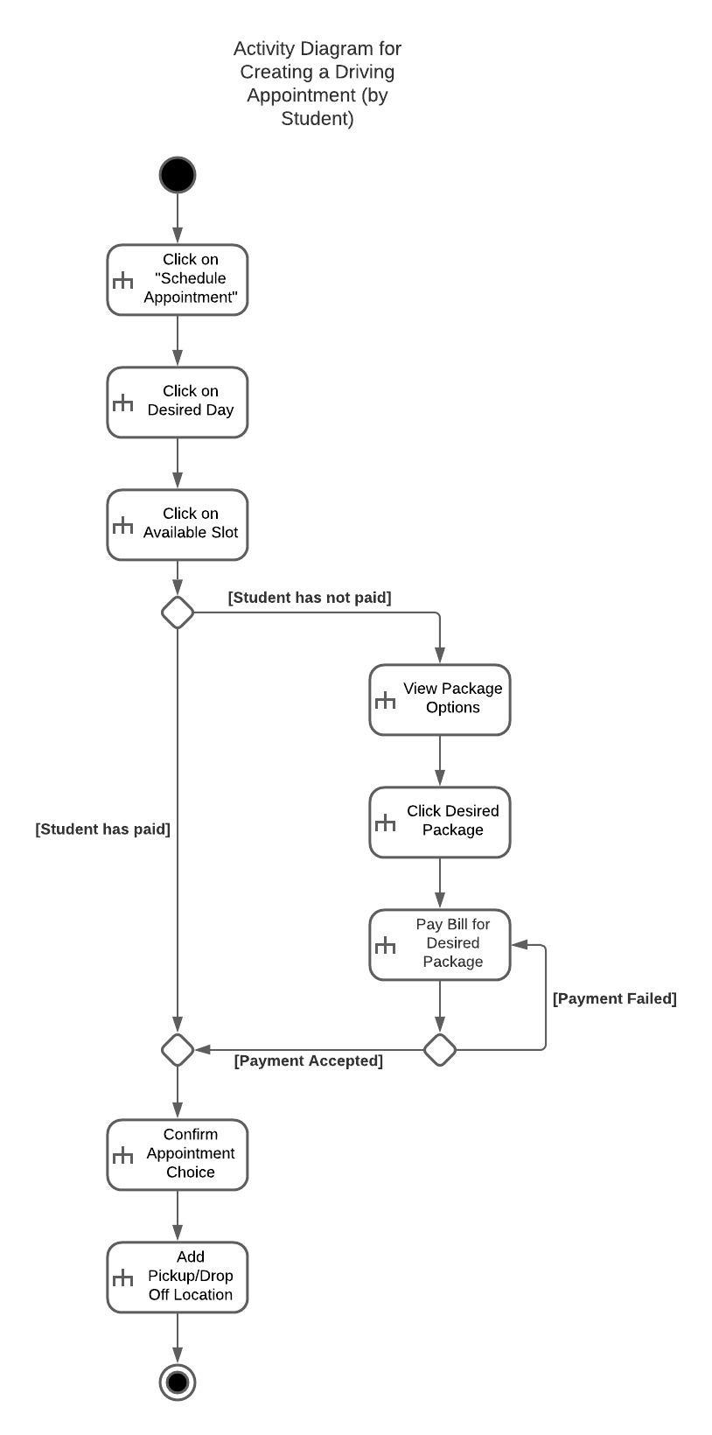

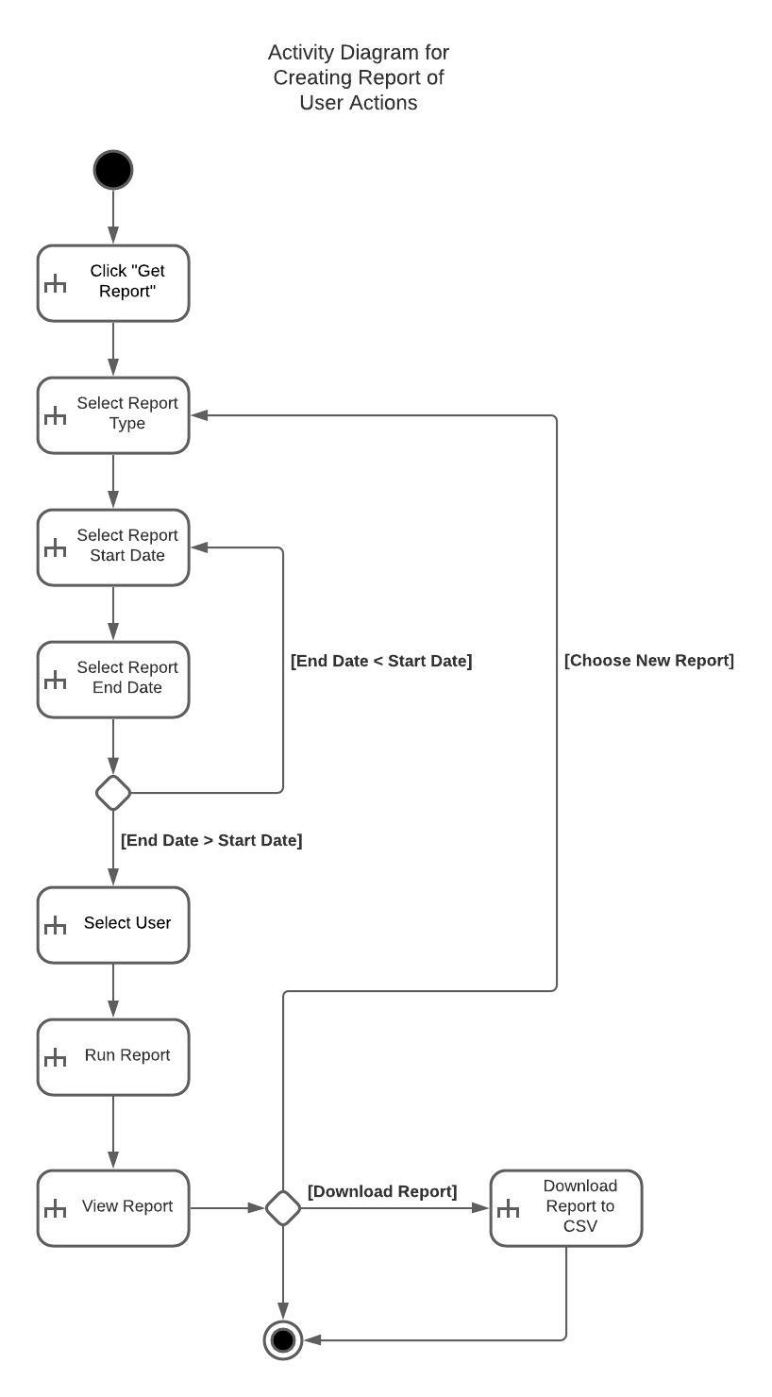

### UML Sequence Diagram

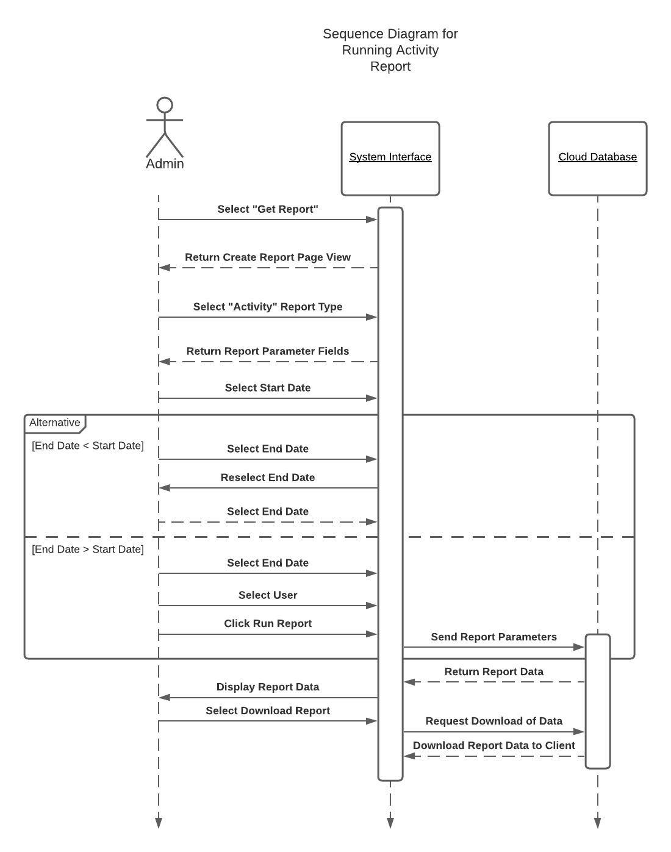

### UML Class Diagram

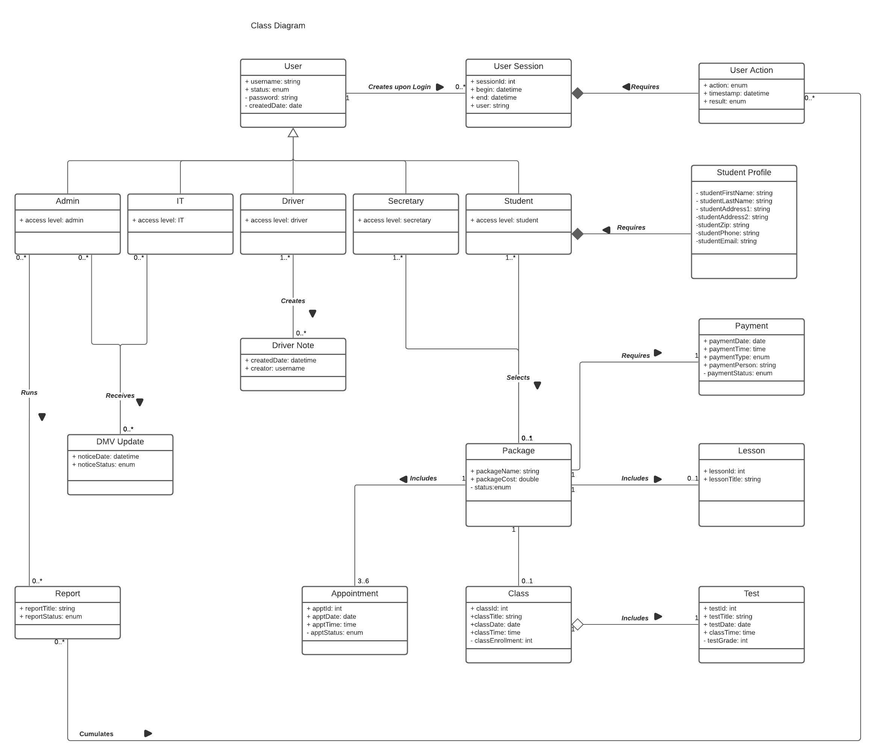

## Technical Requirements

**Hardware**:

The system requires an internet connected client device such as a tablet, computer, or smartphone. It is interacted with using a touchscreen, or a keyboard and mouse. Video playback and sound capability are necessary for certain class materials.

**Software**:

The system requires an internet browser installed on any common desktop operating system such as Windows, MacOS, or Linux, or a mobile device operating system such as iOS or Android. A limited number of website cookies are downloaded in order to store in-session data while the system is used. Each user of the system must possess a unique username and password for authentication, for which they have been registered by a system superuser (Admin). Page and functionality access must be governed by user authorization, according to user type. The system superuser must have the ability to block and/or deactivate user accounts when the student finishes the program, and when employees leave the company. Sensitive information such as payment and personal data must be transmitted in encrypted format. The system must support real-time updates for the sake of keeping an up-to-date appointment calendar and prevent double-booking.

**Tools**:

The system must provide connection monitoring of the DMV interface, with an alert sent to admin users when the connection is disrupted. The system interface must promote security and usability by facilitating error-free user interactions via dropdown menus, multiple selectors, and radio buttons and avoid the use of text fields, except in the Driver Notes feature and other necessary text fields such as in the Student Profile page. Text fields must employ entry validation to prevent errors. All users must have access to resetting and updating their own passwords through a process of identity validation and self-service.

**Infrastructure**:

The server must maintain at least 99.9% uptime, with advanced notice when downtime is expected, preferably on off-hours. The server must accommodate multiple simultaneous users, with the ability to scale horizontally in order to handle more requests as the company grows and the system experiences greater usage, in order that a sub-three second load time can be maintained with increased traffic volume.